PTE Speaking Simulator



Greetings Folks!!! This is my first venture in providing something free. I developed this tool so that I can practice and score well in Speaking test conducted by Pearson (Pearson’s Test of English). I eventually did clear PTE. I just took the toughest among speaking test, “Describe Image” and “Retell Lecture” and created this tool. You can check this and contribute to this tool and enhance it if you think it is worth your effort! I have the source code as well in the same Git repository. You can develop and integrate other modules like “Listening”, “Reading” and “Writing” if you are interested. This is just the beginning!!!

This tool contains two tabs, one for “Describe Image” and the other for “Retell Lecture” as I had mentioned earlier. I will just give a brief of all the controls and what they are intended for in the form of pictures so that it would make sense to most of you…

Please run the “Setup” in your computer and give a new Folder (Create a folder so that all the installation files don’t get mixed up with the existing files in an existing folder!) You will get about 5 files inside the folder after installation. Double click on the “PTE Speaking Simulator” application and you are good to go with your practice.

**Software Requirements**:

You may need Windows 7 and above for this to work smoothly. You may also need .Net 3.5 and above installed in your system for this to work.

**Practice Requirements**:

1. Create sub folders inside your PTE application folder for holding Graphics images and Lecture audio files separately so that it is easy to maintain. For example, you can create

“\PTE Simulator\DescribeImageFIles\” and “\PTE Simulator\LectureAudioFiles\”

1. Search for images and lecture audios in your favourite search engine in the web world and store them in the respective folders (You can search for “PTE Describe Images or PTE Graphs” for images) . Store as many of them as possible so that the tool will choose images at random and you will have the element of surprise lest the images become familiar and defeats the very purpose of this practice.
2. You can get hold of a headset with a microphone to make your recordings clear. When you play back, you can judge how well you did in describing the image or compiling the gist of the lecture. Your recordings will be stored along with the original image or lecture name and the date and time of recording. You can even compare how you have improved, if the same image repeats after some iterations. This will definitely boost your confidence!

**A Peek into the tool**:

**Describe Image**: Please check these images for instruction on using the controls

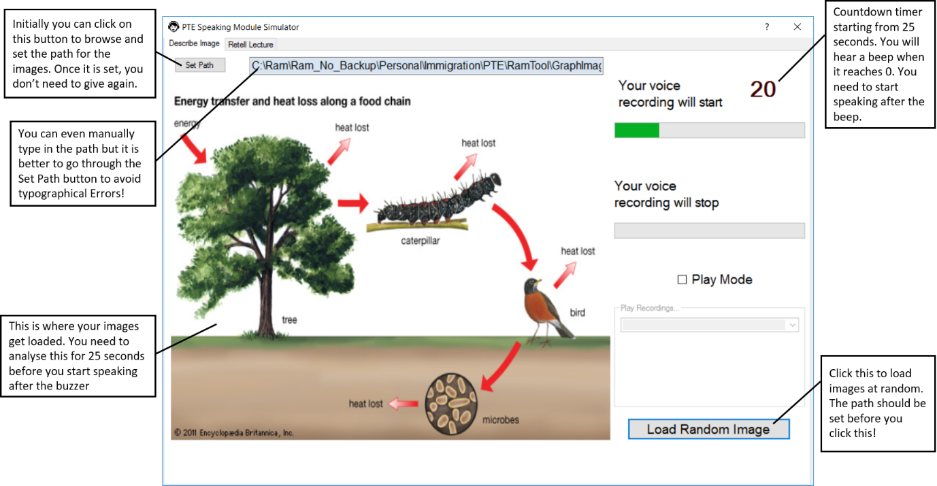

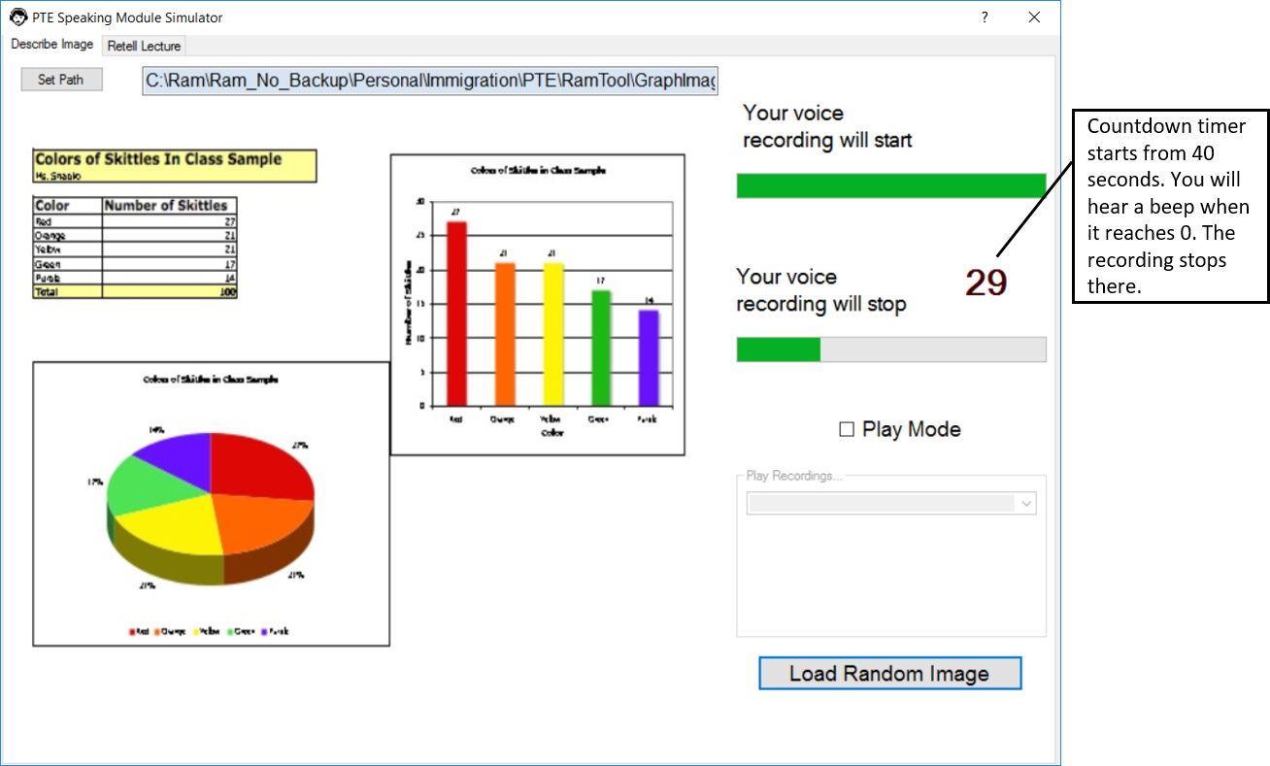

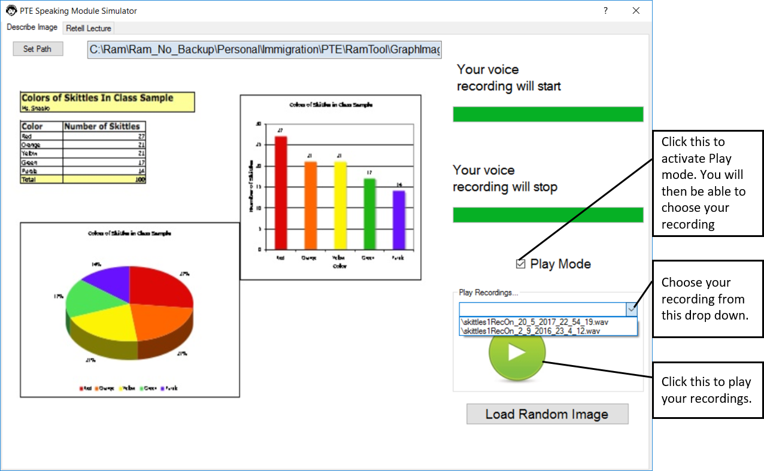

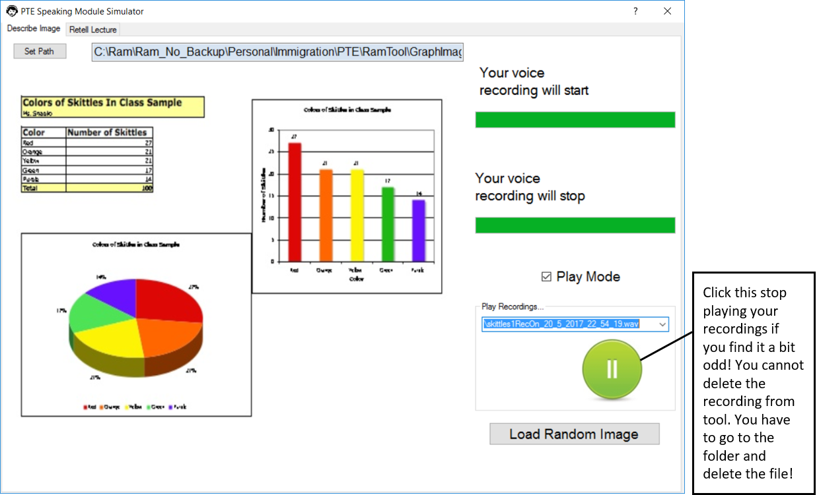

**Retell Lecture**: Please check these images for instruction on using the controls

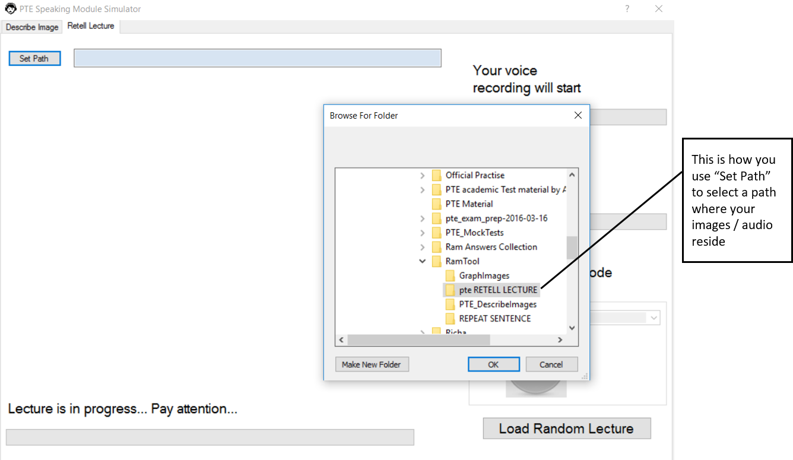

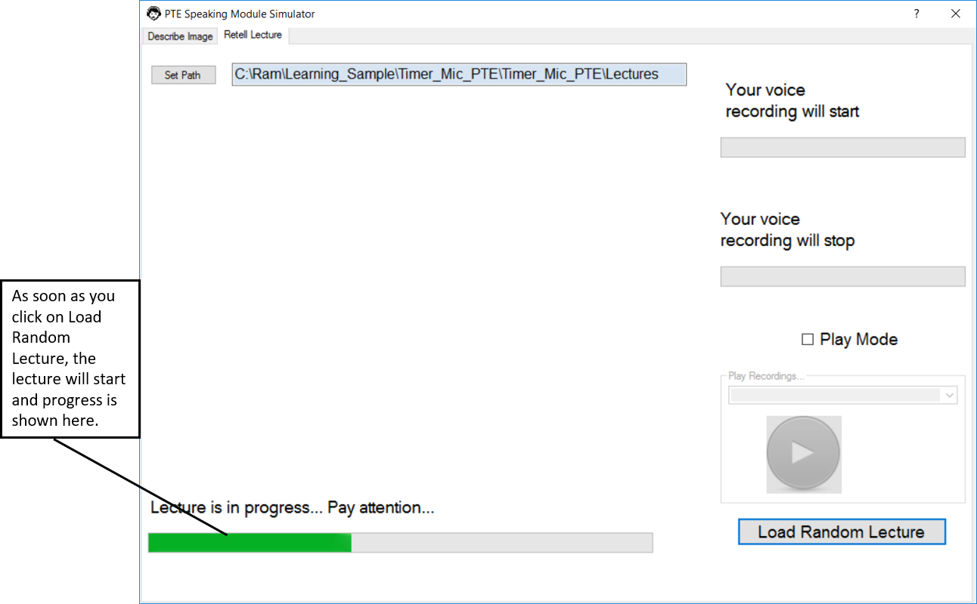

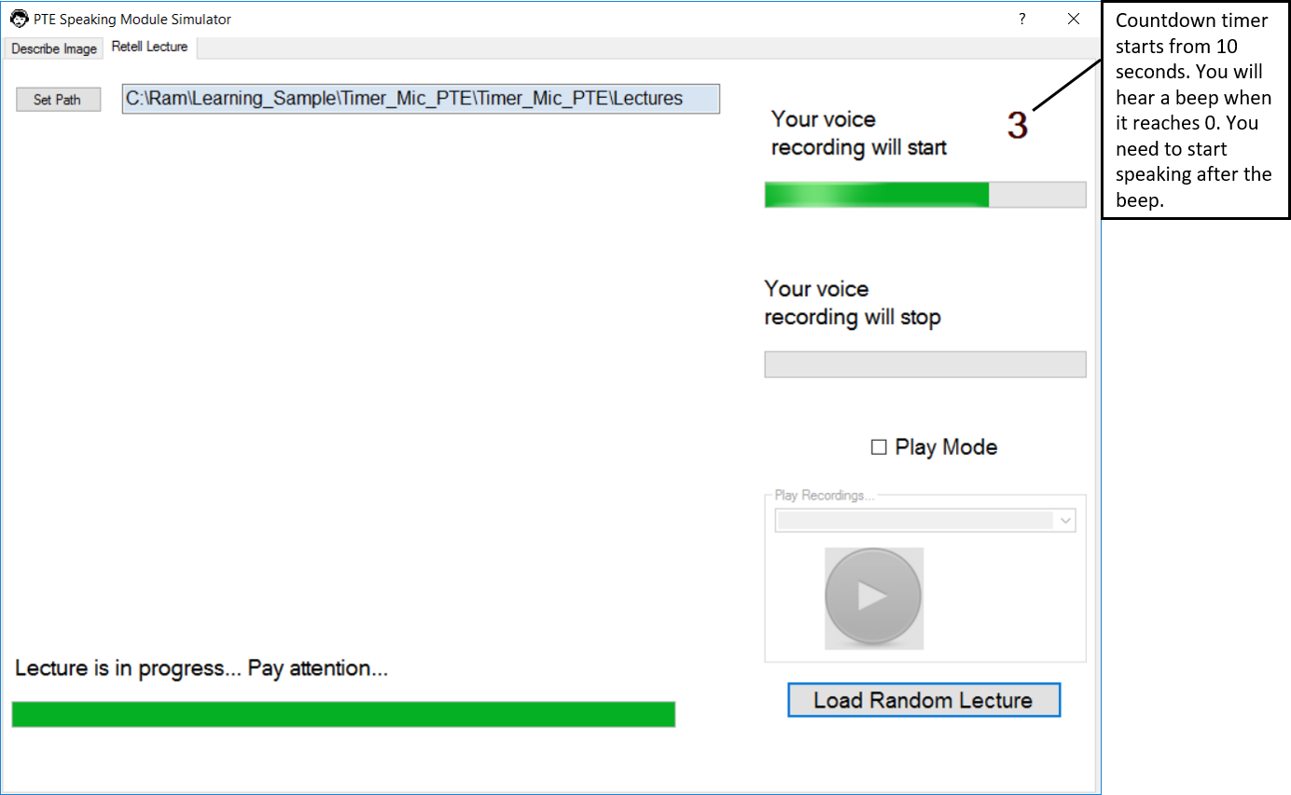

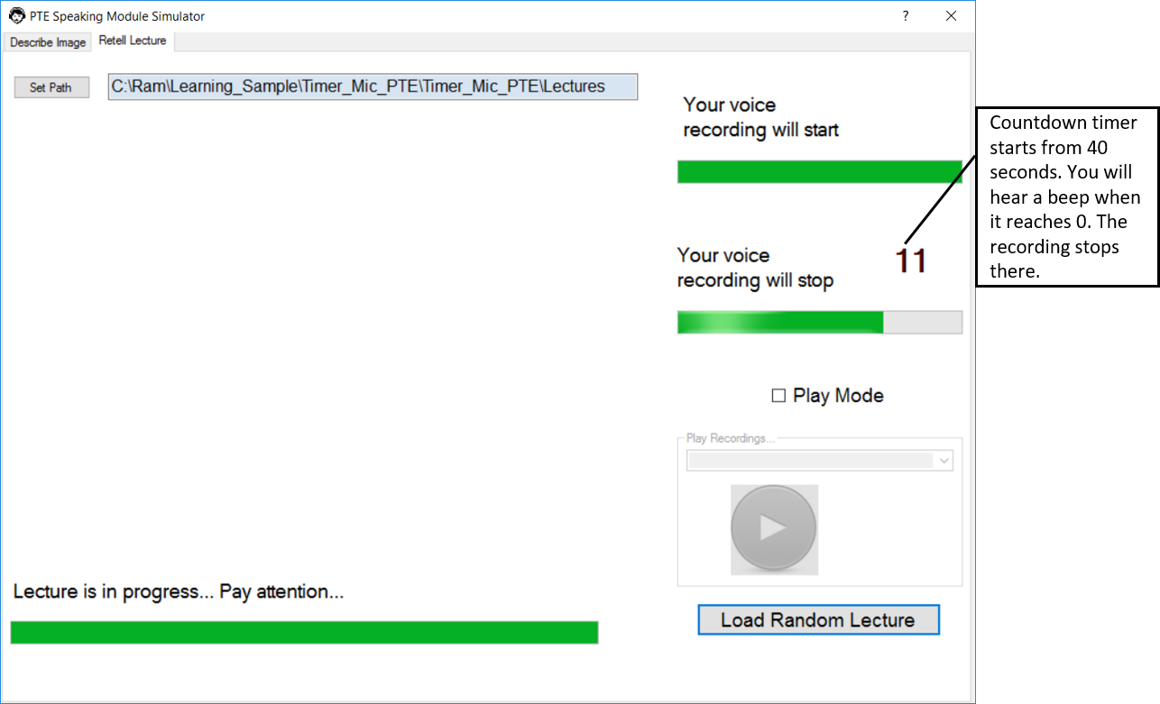

**Disclaimer**:

1. This is a pre-pre-Alpha version and not tested extensively. Hence please bear with the bugs and if possible make appropriate correction in the code and commit in the Git repository! Worst case, you may have to close and open the application as we do in any windows based application! Once again, I request you to not curse me (😊) but forgive me when you encounter bugs since I don’t have enough time now for extensive testing and bug correction at the moment. When I get a chance, I will improve this release and share it again! Please keep checking this space for future releases.
2. The timers are designed as per the current exam pattern. If they are changed, please don’t hold me responsible. Check the latest exam pattern from Pearson’s official website and then use this tool to practice.
3. I have covered just 10% of the sections that the actual exam has. If you interested in covering all the sections, please feel free to enhance the tool. The source code resided in this Git repository. It might be very useful for people who take the test if we can give a comprehensive practice tool.

**Good Luck on your PTE exam**

Thanks

**Ramanathan (Ram) Balakrishnan**

[ramnath_b@yahoo.com](mailto:ramnath_b@yahoo.com)